MCXess
User guide for SSO, two-factor authentication and account settings
For customers who want to log in to the MCXess platform securely and easily.
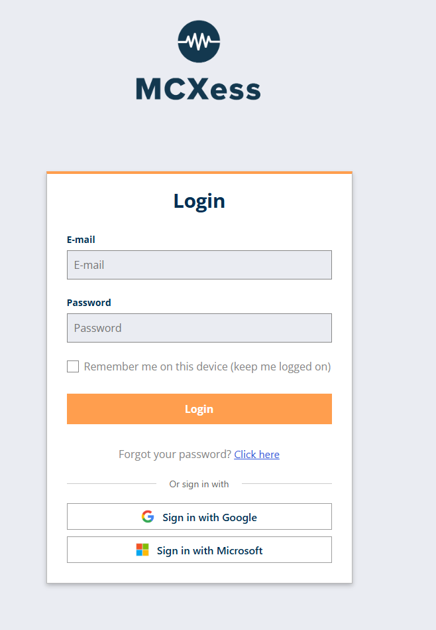
Important: Always use your full business email address. Never share your password, QR code or verification code with anyone.

1. Logging in and Single Sign-On (SSO)
You can log in with your MCXess password or with a linked Google or Microsoft account.
1 | Choose your login method  Use one of the following options:  - Standard login: enter your full email address and MCXess password and click Login.  - SSO with Google: click Sign in with Google.  - SSO with Microsoft: click Sign in with Microsoft.  SSO only works after the relevant Google or Microsoft account has been linked to your MCXess account via the Security tab.

2. Resetting your password
Follow these steps if you have forgotten your MCXess password.
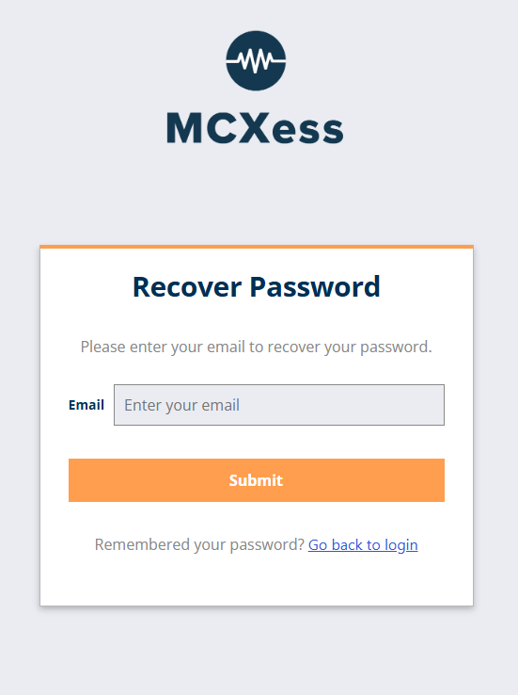
2 | Request a new password  On the login screen, click Click here next to Forgot your password?. Then enter your full email address and click Submit.

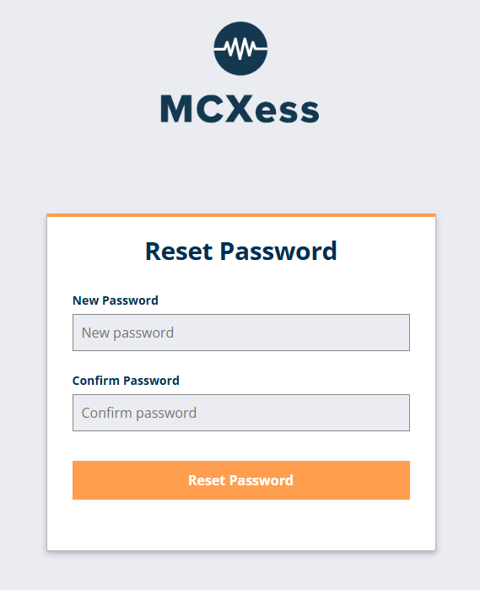
3 | Open the unique reset link  You will receive an email containing a personal, one-time URL. Open this link and enter the same new password twice.  Didn't receive an email? Also check your Junk Email or Spam folder. Only then request a new reset link.

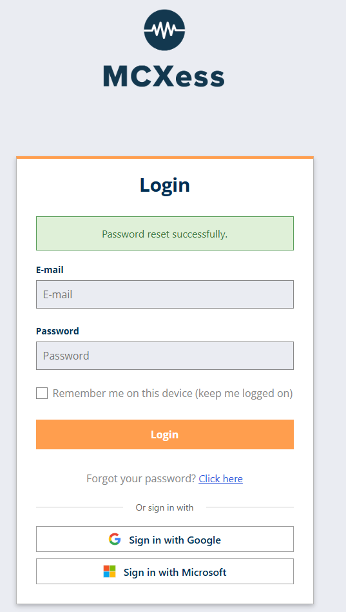
4 | Confirm the new password  Click Reset Password. After a successful change, the message Password reset successfully will appear. You can then log in immediately using the new password.

Secure password: Use a unique password that you do not use for other services. A longer passphrase is usually easier to remember and harder to guess.

3. Logging in with email verification
For some sign-ins, MCXess verifies your identity using a verification code sent by email.
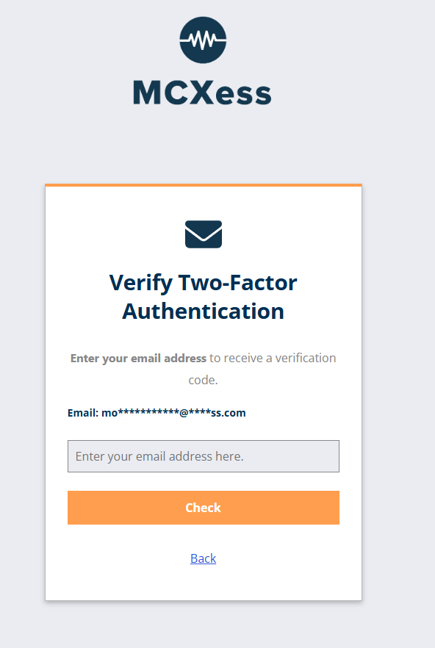
5 | Confirm your full email address  Enter your full email address on the verification screen. The address must exactly match the email address associated with your MCXess account. Then click Check.

6 | Enter the code you received  MCXess sends a temporary verification code to your email address. Open the message, enter the code on the verification screen and click Verify. After successful verification, you will be logged in.  A verification code is valid for a limited time. Request a new code if the previous code is no longer accepted.

4. Viewing account details
After logging in, you can review your registered account details.
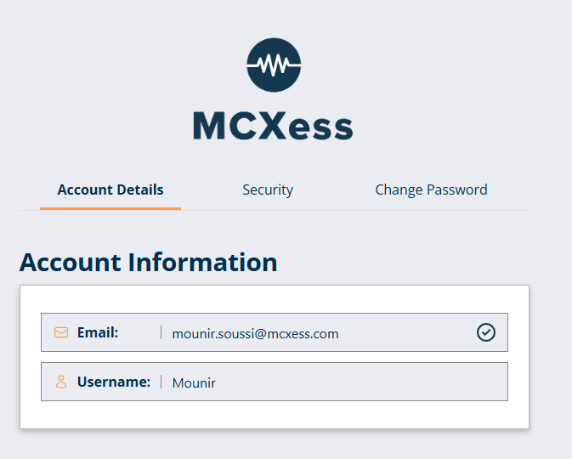
7 | Open Account Details  In the Account Details tab, you can see the email address and username linked to your MCXess account. Check these details before configuring SSO or 2FA.

5. Linking Google or Microsoft for SSO
Use the Security tab to link an external account to MCXess. You can then use the corresponding SSO button on the login screen.
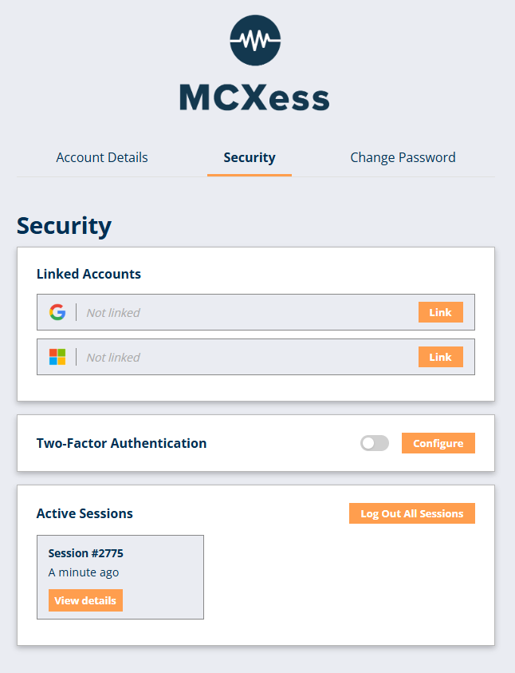
8 | Start linking the account  Click Link next to Google or Microsoft. You will be redirected to the secure sign-in page of the selected provider.

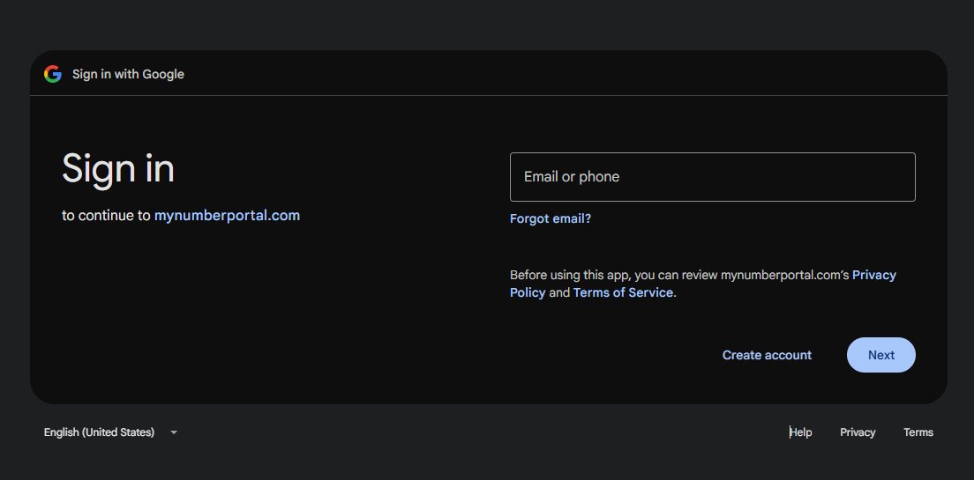
9 | Link a Google account  On the Google page, enter your email address or phone number and click Next. Then enter your Google password and complete any additional security checks. After granting permission, you will be redirected back to MCXess.

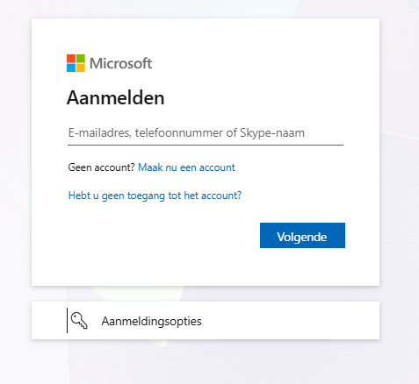

10 | Link a Microsoft account  On the Microsoft page, enter your email address and click Next. Then enter your Microsoft password and complete any additional security checks. After granting permission, you will be redirected back to MCXess.

Check: In the Linked Accounts section, the status should change from Not linked to a linked status after the account has been linked successfully.

6. Setting up two-factor authentication (2FA)
With 2FA, a temporary code from an authenticator app is required in addition to your password. This reduces the risk of unauthorized access.
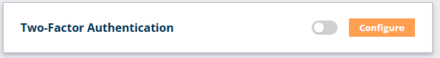
11 | Open the 2FA configuration  Go to Security and click Configure next to Two-Factor Authentication.

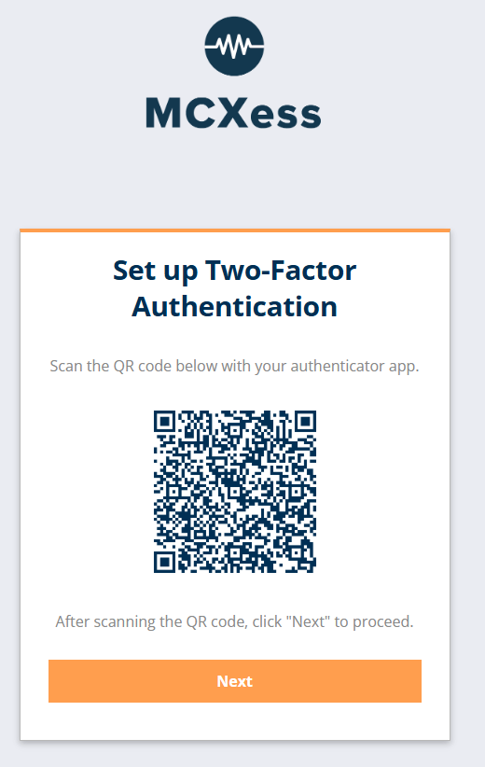
12 | Display the QR code in MCXess  After clicking Configure, a unique QR code will appear. Keep this screen open while setting up the authenticator app on your phone.  The QR code provides access to your 2FA configuration. Do not share the QR code or take a photo of it.

Google Authenticator
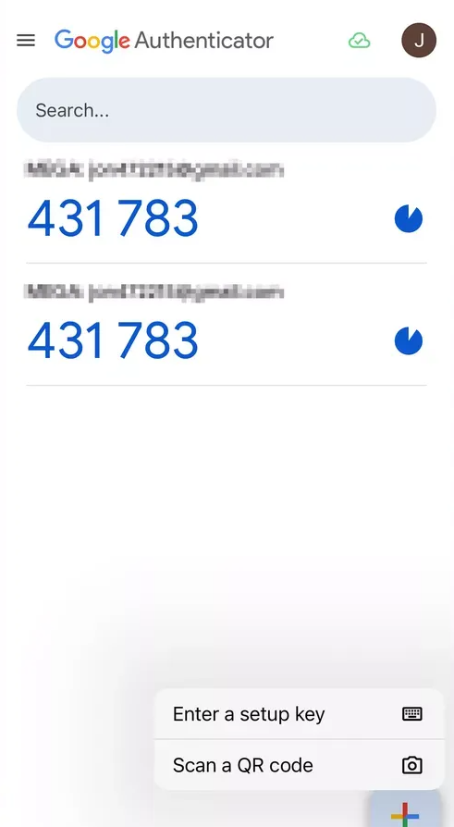
13 | Add the QR code in Google Authenticator  Open Google Authenticator, tap + at the bottom right and select Scan a QR code. Point the camera at the QR code in MCXess. The MCXess verification code will then be added automatically.

Microsoft Authenticator
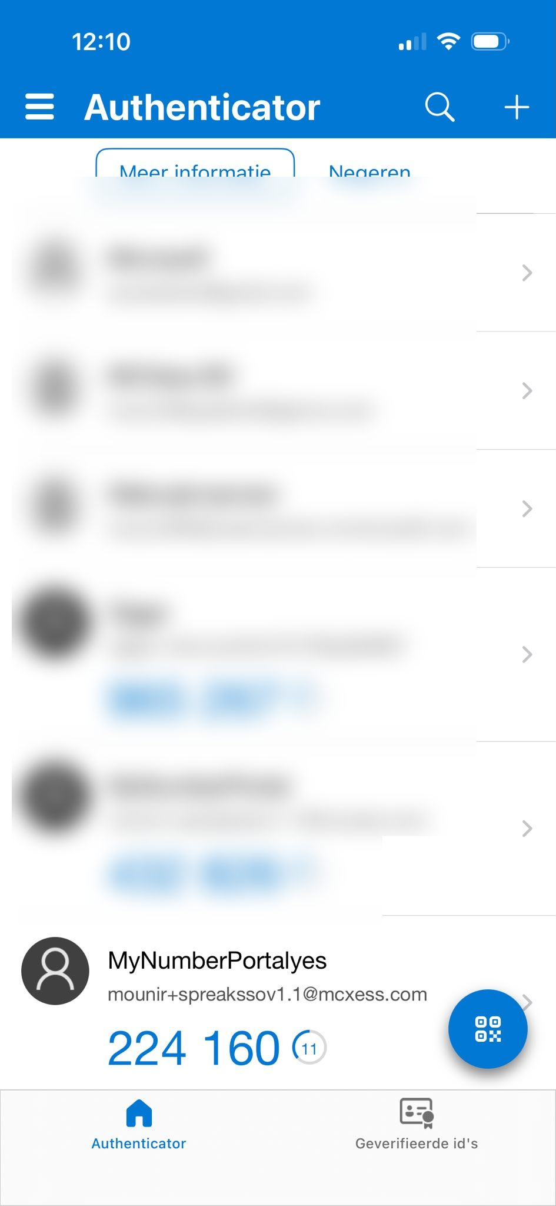
14 | Add the QR code in Microsoft Authenticator  Open Microsoft Authenticator and tap + at the top right. Choose Other account or Work or school account and select Scan QR code. Point the camera at the QR code in MCXess. The new MCXess account will then appear in the app.  The account names and verification codes in the image have been obscured for privacy. The blue QR button at the bottom right can also be used to scan a QR code.

15 | Confirm the temporary code  The authenticator app displays a six-digit code that is refreshed regularly. Enter the current code in MCXess and confirm the configuration. When 2FA is active, this will be shown in the Security tab.

At your next sign-in: Open your authenticator app, enter the current six-digit code and confirm the sign-in before the code expires.

7. Other security settings
You can also review active sessions in the Security tab.
16 | Review active sessions  Under Active Sessions, you can see where your account is currently signed in. Click View details to see additional information about a session.

17 | Log out all sessions  Use Log Out All Sessions if you suspect that your account is signed in on an unknown or lost device. You will then be logged out on all devices and will need to sign in again.

18 | Change password  Open the Change Password tab when you want to replace your current password as a precaution. Again, use a unique password and preferably store it in a trusted password manager.

Support: Contact support@mcxess.com if you can no longer access your account.

